NAME: SAGARSUMAN P MANJHI SUBJECT: PYTHON PROGRAMMING LAB | PRACTICAL: 09 | BATCH : 04  SYBVOC :SEM-III (DS)
EXPERIMENT BASED ON EXCEPTION HANDLING

AIM : To study and implement exception handling in Python using try, except, else, finally, and user-defined exceptions by developing an Online Banking Transaction System that validates withdrawal amounts and account balance while handling invalid inputs.
LEARNING OBJECTIVE :
  - To understand exception handling in Python.
  - To learn the use of try, except, else, and finally blocks.
  - To handle runtime errors and invalid user inputs.
  - To create and raise user-defined exceptions.
  - To validate account numbers and withdrawal amounts.
  - To implement a simple banking transaction system.
TOOLS :
Sr. No. | Name Of Resources | Specification | Quantity | Remarks
1. | Hardware | Computer (i5-i7) Ram (Min 16GB) | 1 | For All Practical
2. | Software | Python / IDLE / VS Code | 1 | For All Practical
THEORY :
Exception handling is a mechanism in Python used to manage errors that occur during program execution. It prevents a program from terminating unexpectedly and allows appropriate error messages to be displayed.
In this practical, an Online Banking Transaction System is developed to validate the account number, check the withdrawal amount, and ensure that sufficient balance is available before processing a transaction.
Concepts Used
- try block: Contains statements that may generate exceptions.
- except block: Handles exceptions raised during program execution.
- else block: Executes when the try block completes without an exception.
- finally block: Executes whether an exception occurs or not.
- raise statement: Explicitly raises an exception when a condition is not satisfied.
- Built-in Exceptions: ValueError is used when account details or withdrawal amounts are invalid.
- User-Defined Exceptions: InsufficientBalanceError is created to handle withdrawals exceeding the available balance.
- Input Validation: The program checks whether the account number contains exactly ten digits and whether the withdrawal amount is positive.
Creating a user-defined exception
class InsufficientBalanceError(Exception):
pass
Source Code:
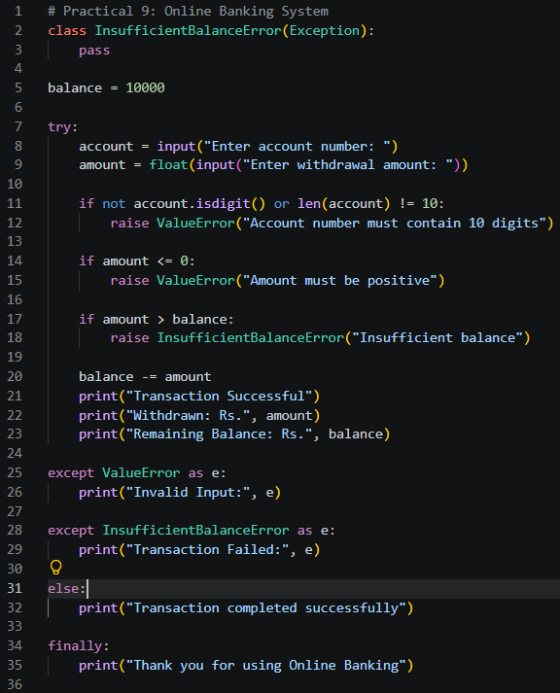
Output:
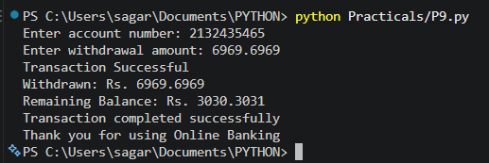
Result and Discussion:
The Online Banking Transaction System was implemented successfully using Python exception handling.The program uses ValueError for invalid account details or non-positive withdrawal amounts and a user-defined InsufficientBalanceError when the withdrawal exceeds the available balance. The else block displays a completion message when no exception occurs, while the finally block displays a thank-you message in all cases.
The balance is maintained only during the execution of this program and is not saved permanently.
Learning Outcomes:
- Learned to use try, except, else, and finally blocks.
- Applied built-in exceptions to handle invalid inputs.
- Created and raised a user-defined exception.
- Implemented account number and withdrawal validation.
- Developed a basic banking transaction program with error handling.
Course Outcomes:
- Understand exception handling concepts in Python.
- Apply exception handling to manage invalid inputs and runtime errors.
- Create and use user-defined exceptions.
- Develop a Python application with appropriate error-handling mechanisms.
CONCLUSION :
The Online Banking Transaction System was developed successfully using Python exception handling. The program validates account details, checks the withdrawal amount and available balance, and handles errors using built-in and user-defined exceptions. The practical demonstrates how exception handling improves program reliability and helps manage invalid inputs safely.

VIVA QUESTIONS :
Q1. What is exception handling in Python?
Exception handling is a mechanism for detecting and managing errors during program execution.
Q2. What is the purpose of the try block?
It contains code that may raise an exception.
Q3. What is the purpose of the except block?
It handles an exception raised in the try block.
Q4. What is the use of the else block?
It executes when the try block completes without raising an exception.
Q5. What is the purpose of the finally block?
It executes whether an exception occurs or not, making it useful for cleanup operations.
FOR FACULTY USE ONLY :
Correction Parameters | Formative Assessment [40%] | Timely completion of practical [40%] | Attendance/ Learning Attitude [20%]
Marks Obtained

